Ex.No: 1 | Electricity Bill Calculator
Date: | Electricity Bill Calculator

Aim:

To create a Java console application used to generate electricity bill based on connection type (Domestic and Commercial) and consumption. Both are having different tariff slots.

Algorithm:

Step 1 | Start the process
Step 2 | Get the user informations [Name, Consumer Number, Reading’s of previous and current month, Connection Type]
Step 3 | Compute units consumed by user [Current Month Reading – Previous Month Reading]
Step 4 | If a connection type is domestic goto step 6
Step 5 | Else goto step 7
Step 6 | Initialize i with 1 and sum as 0
 | Step 6.1 | If check i is less than or equal to 100 then compute sum = sum + 1 and goto step 6.5
 | Step 6.2 | Else if check i is greater than 100 and less than 200 then compute sum = sum + 2.5 and goto step 6.5
 | Step 6.3 | Else if check i is greater than 200 and less than 500 then compute sum = sum + 4 and goto step 6.5
 | Step 6.4 | Else compute sum = sum + 6 and goto step 6.5
 | Step 6.5 | If i is equal to number of units consumed goto step 8 else return to same step
Step 7 | Initialize i with 1 and sum as 0
 | Step 7.1 | If check i is less than or equal to 100 then compute sum = sum + 2 and goto step 7.5
 | Step 7.2 | Else if check i is greater than 100 and less than 200 then compute sum = sum + 4.5 and goto step 7.5
 | Step 7.3 | Else if check i is greater than 200 and less than 500 then compute sum = sum + 6 and goto step 7.5
 | Step 7.4 | Else compute sum = sum + 7 and goto step 7.5
 | Step 7.5 | If i is equal to number of units consumed goto step 8 else return to same step
Step 8 | Store the sum
Step 9 | Display Bill Details [Name, Consumer Number, No of units consumed]
Step 10 | Check the connection type
 | Step 10.1 | If connection type is domestic display domestic tariff slot and goto step 11
 | Step 10.1 | Else display commercial tariff slot and goto step 11
Step 11 | Display amount payable using stored sum
Step 12 | Stop the Process
Coding

import java.util.Scanner;
class EBConsumer {

int consumer_number;
String consumer_name;
int previous_month_reading;
int current_month_reading;
int units_consumed;
boolean isDomestic = false;
double bill_ammount;

public void displayDomesticFares(){
System.out.println("Domestic Fare Details");
System.out.println("*********************");
System.out.println("First 100 units - Rs. 1 per unit");
System.out.println("101-200 units - Rs. 2.50 per unit");
System.out.println("201 -500 units - Rs. 4 per unit");
System.out.println("> 501 units - Rs. 6 per unit");
}

public void displayCommercialFare() {
System.out.println("Commercial Fare Details");
System.out.println("***********************");
System.out.println("First 100 units - Rs. 2 per unit");
System.out.println("101-200 units - Rs. 4.50 per unit");
System.out.println("201 -500 units - Rs. 6 per unit");
System.out.println("> 501 units - Rs. 7 per unit");
}

public void getDetails() {
Scanner inputs = new Scanner(System.in);
System.out.println("Welcome To EB Calculater\n\n");
System.out.println("Please Enter Your Name : ");
this.consumer_name = inputs.next();
System.out.println("Please Enter Your Consumer Number : ");
this.consumer_number = inputs.nextInt();
System.out.println("Please Enter Your Previous Month Reading : ");
this.previous_month_reading = inputs.nextInt();
System.out.println("Please Enter Your Current Month Reading : ");
this.current_month_reading = inputs.nextInt();
System.out.println("Is this domestic Connection (yes/no) : ");
if(inputs.next().equals("yes"))
this.isDomestic = true;
}

public void generateBill(){
int number_of_units_consumed = this.current_month_reading - this.previous_month_reading;
this.units_consumed = number_of_units_consumed;
double sum = 0;
if(isDomestic == true) {
for (int i = 0; i <= number_of_units_consumed; i++) {
if (i <= 100)
sum = sum + 1;
else if (i > 100 && i <= 200)
sum = sum + 2.5;
else if (i > 200 && i <= 500)
sum = sum + 4;
else
sum = sum + 6;
}

}
else {
for (int i = 0; i <= number_of_units_consumed; i++) {
if (i <= 100)
sum = sum + 2;
else if (i > 100 && i <= 200)
sum = sum + 4.5;
else if (i > 200 && i <= 500)
sum = sum + 6;
else
sum = sum + 7;
}
}
this.bill_ammount = sum;
}

public void displayBill() {
generateBill();
System.out.println("The EB Bill Details");
System.out.println("*******************");
System.out.println("Consumer Number : "+this.consumer_number);
System.out.println("Consumer Name : "+this.consumer_name);
System.out.println("Consumer Units Consumed:"+this.units_consumed);
if(this.isDomestic == true)
System.out.println("Your are an Domestic Consumer\nFare Details ...");
else
System.out.println("You are a Commercial Consumer\nFare Details ...");
System.out.println("\nAmount Payable is \u20B9: "+this.bill_ammount);
}
}

public class Main {

public static void main(String[] args) {
EBConsumer consumer = new EBConsumer();
consumer.getDetails();
consumer.displayBill();
}
}

Output:

User type is domestic:

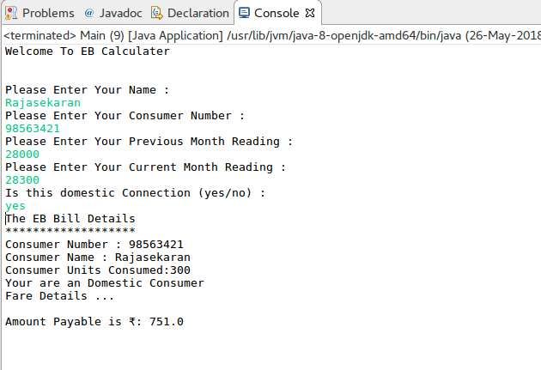
User type is commercial:

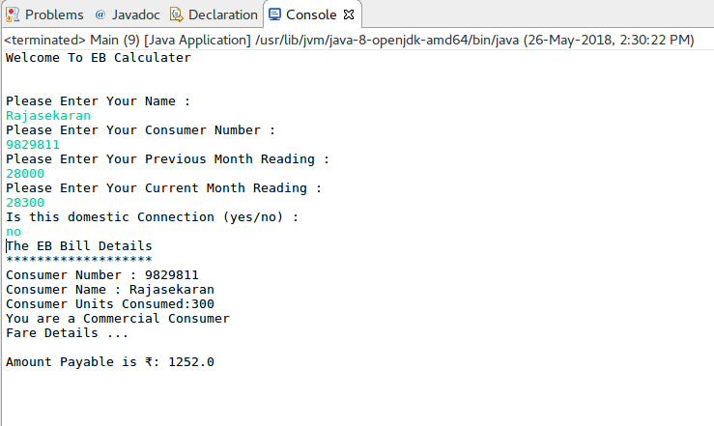

Result:

The Java console application for electricity bill generator was developed and tested successfully.

